**Experiment-9**

1)Create a directory for storing the config files



2)Create a main.tf terraform file in the directory

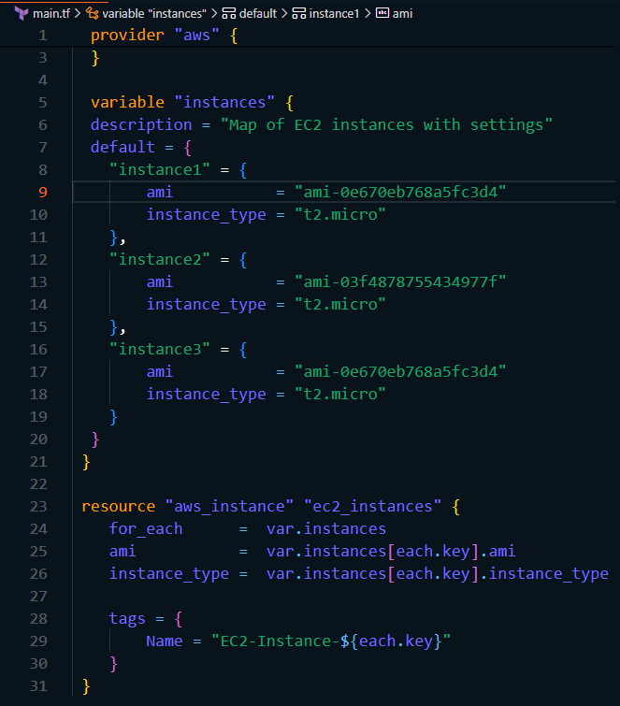

2)Run terraform init and terraform apply command

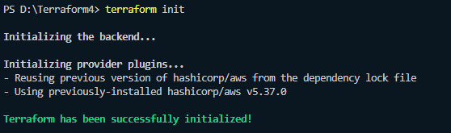

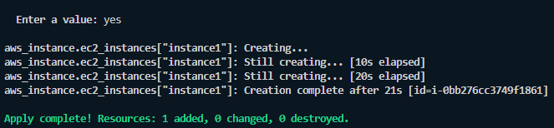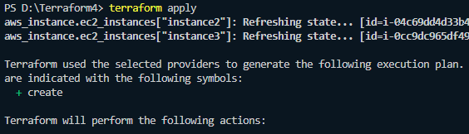

3)Check on the aws ec2 dashboard for the instances

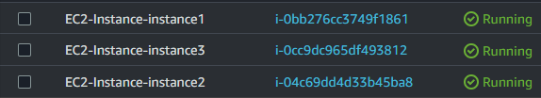

4)Run terraform destroy to remove all the resources

